**4) Screenshots of Chat Analysis Project**

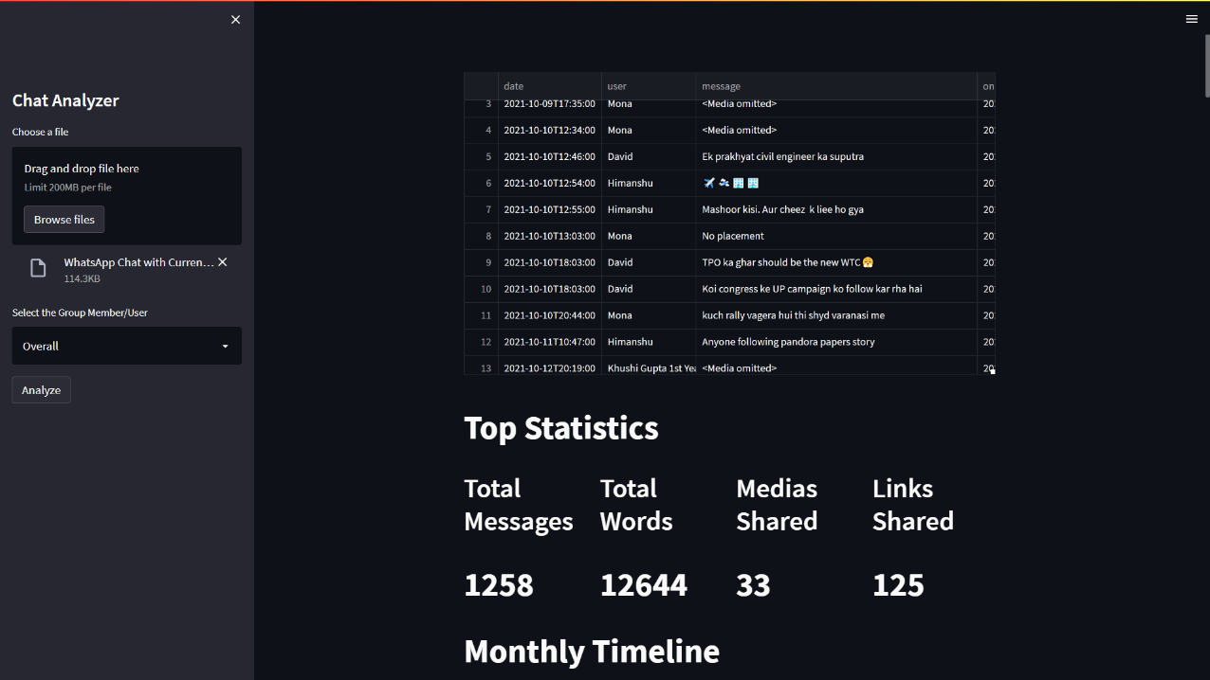

* 1. Data box showing the chats

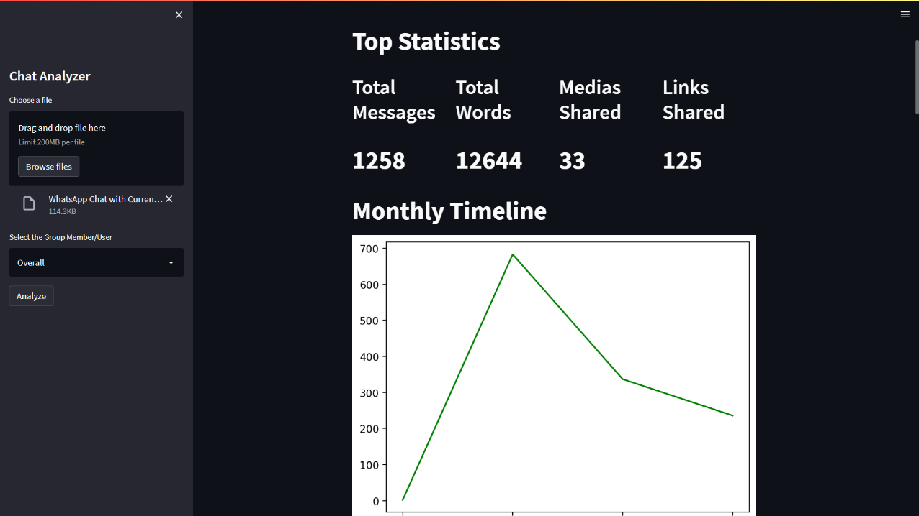

b.Top Statistics of the chat summarizing total number of messages, total number of words, Medias shared and Links shared.

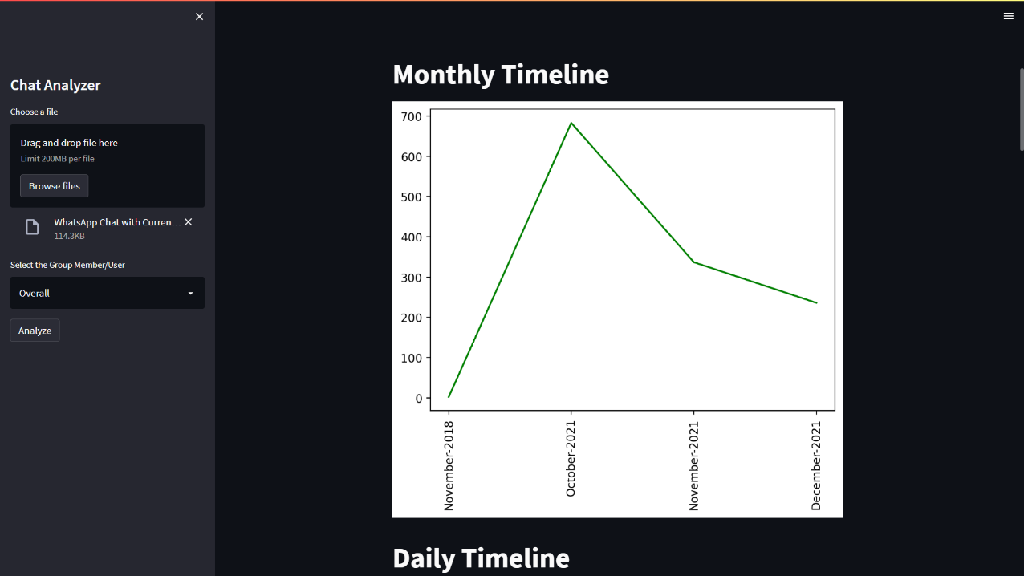

c.Graph showing the Monthly timeline of messages

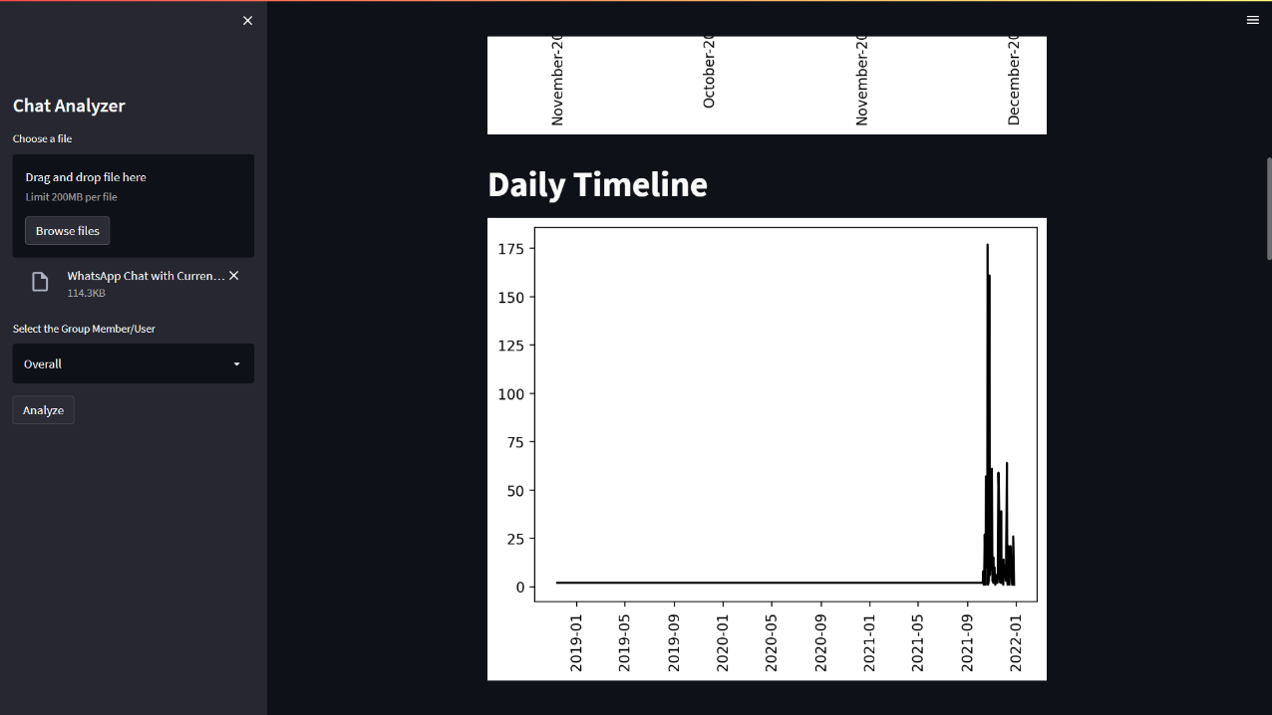

d.Graph showing the daily timeline of messages

e.Activity Maps

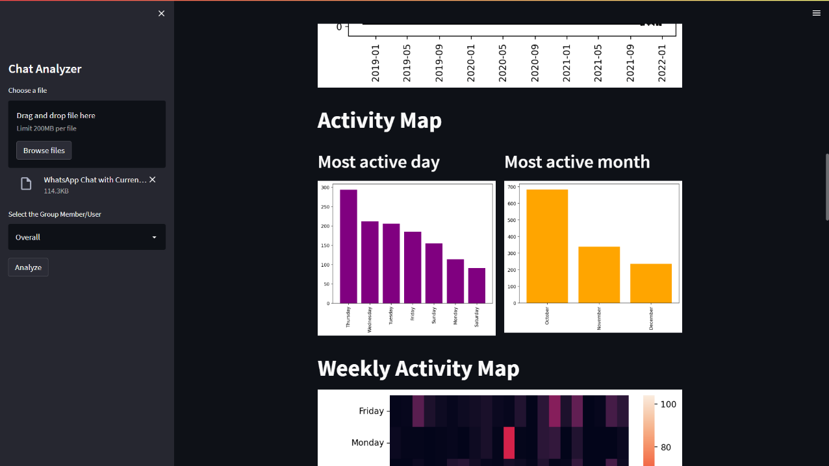

e.1 and e.2 Graph showing most active day and month

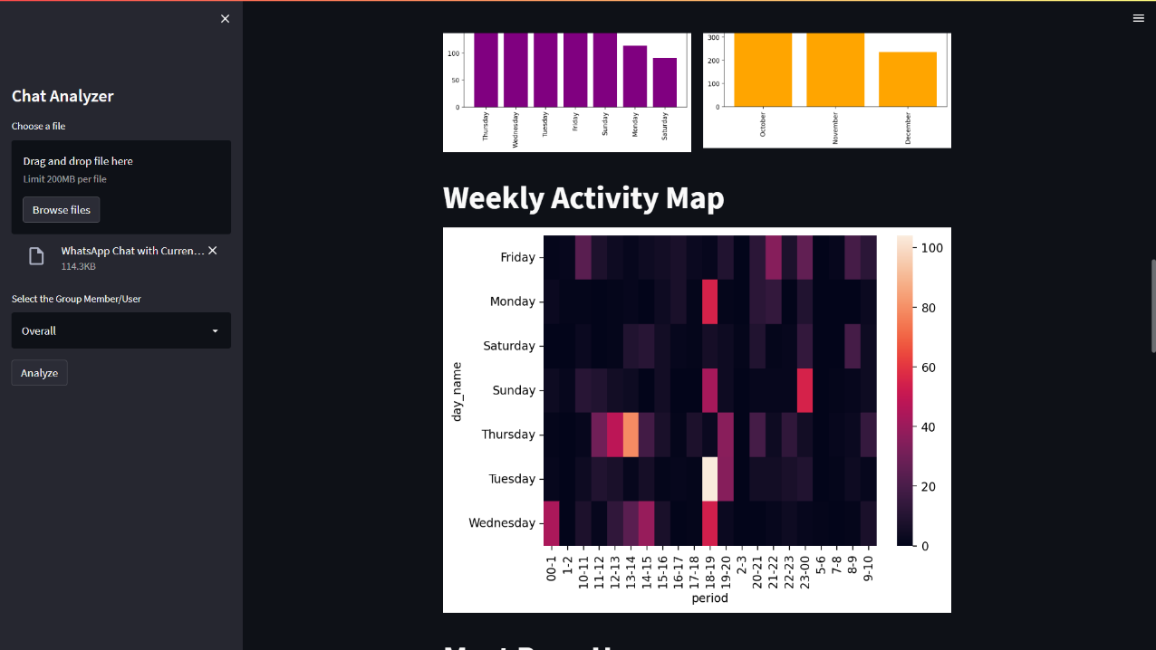

e.3. Heatmap showing weekly distribution of messages

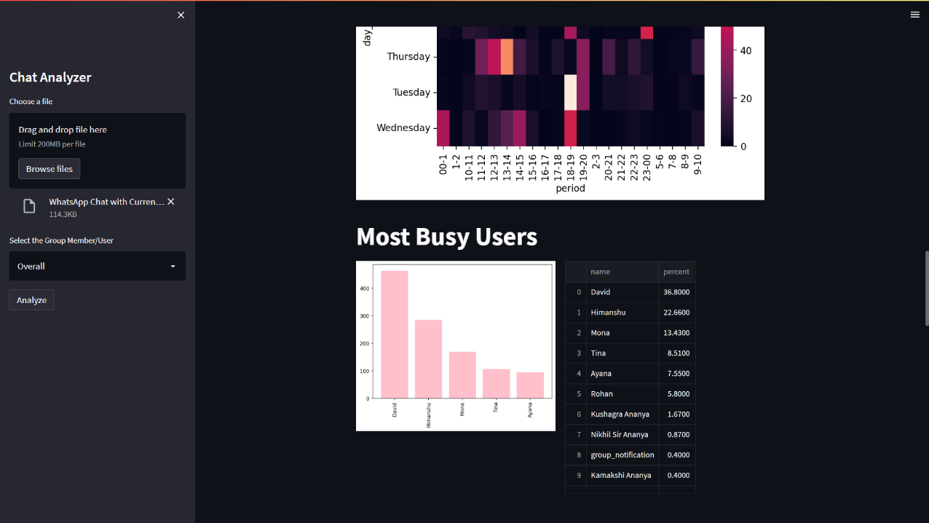

e.3 Graph showing most busy users with a table with percentages of their contribution beside it.

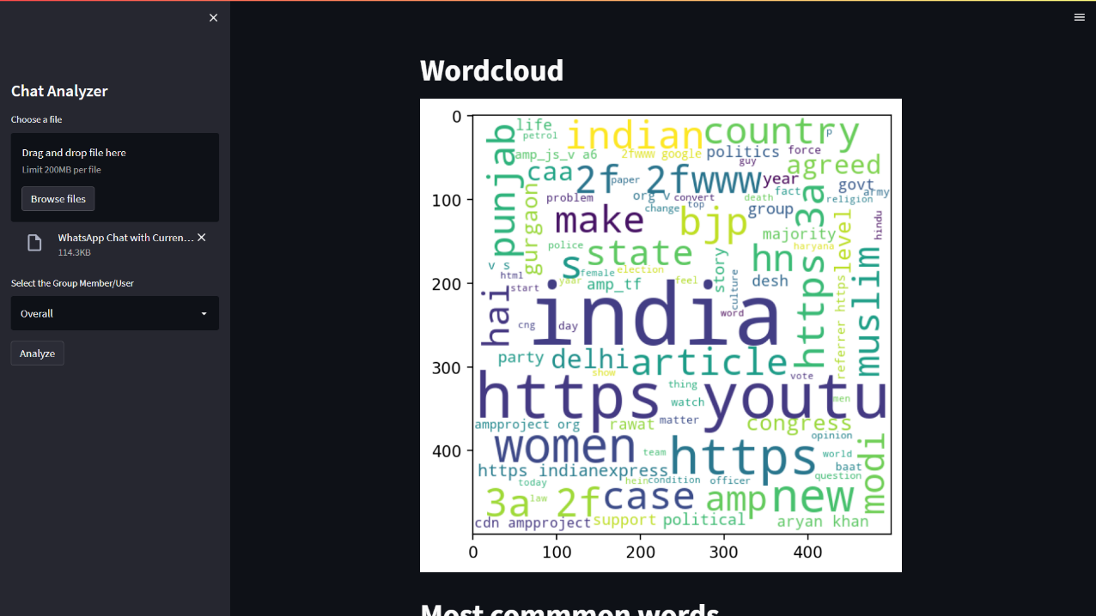

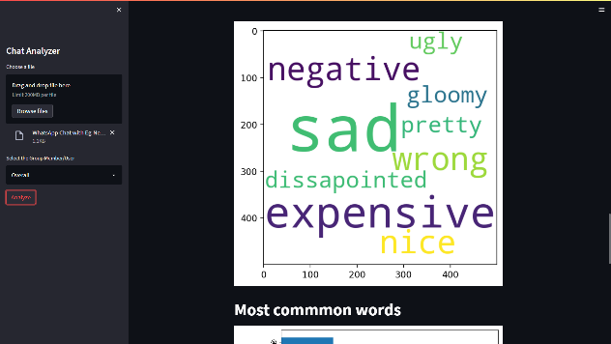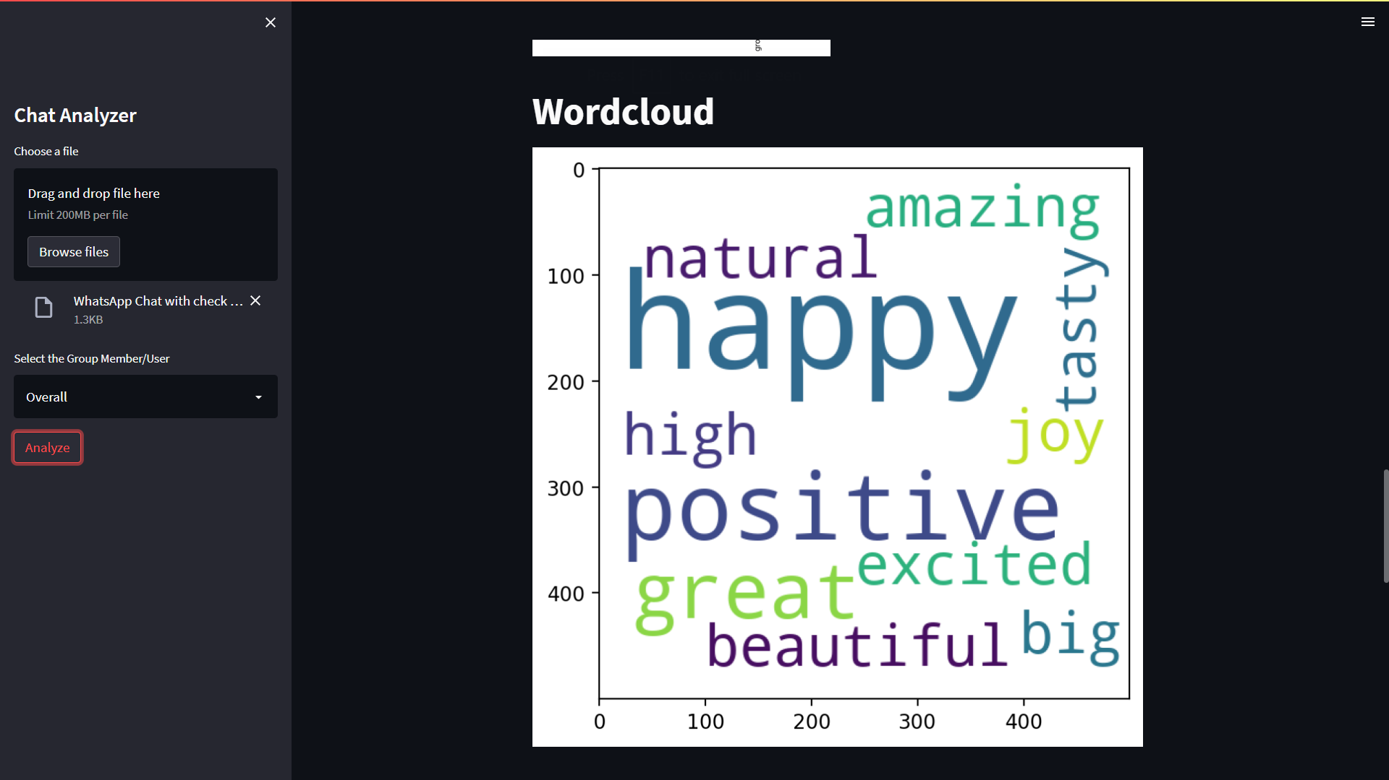

f. WordClouds showing most used words.

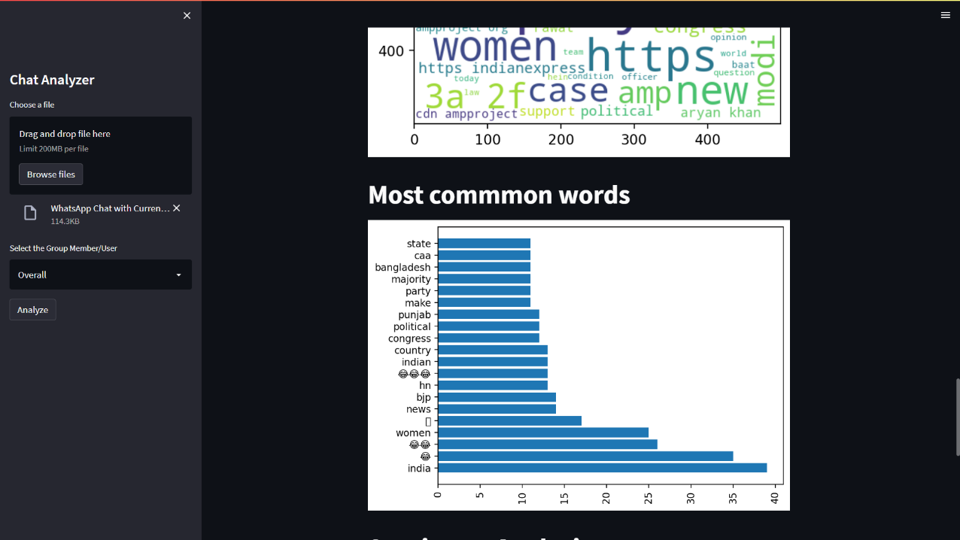

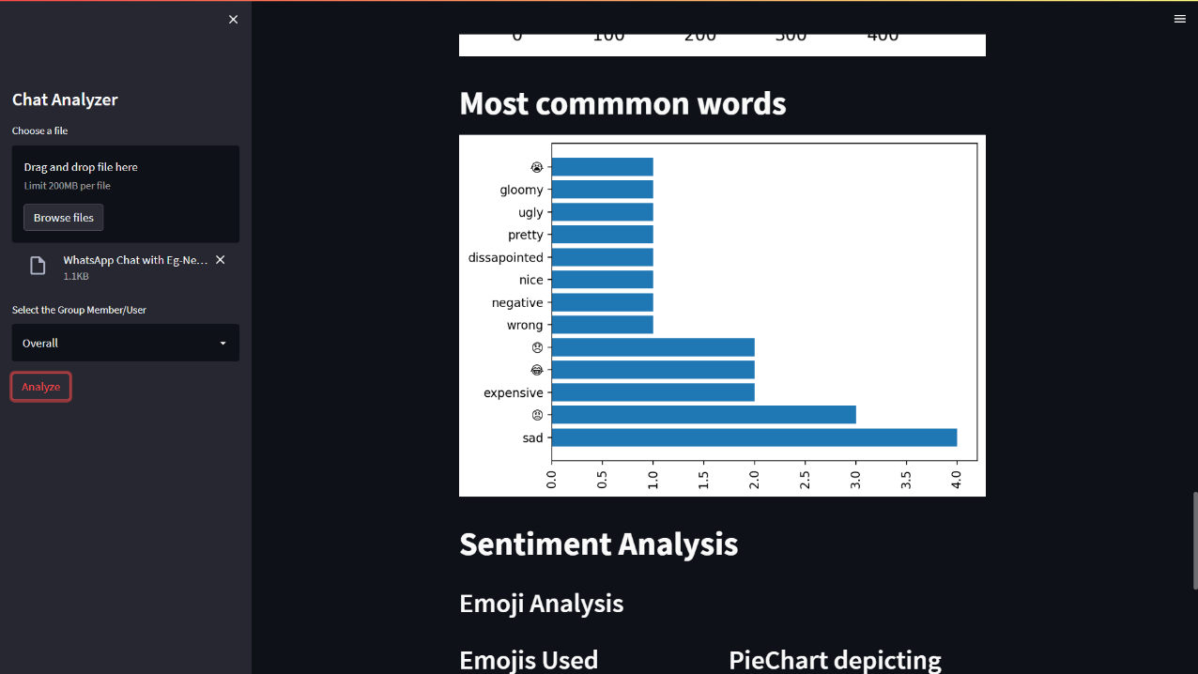

g. WordCloud and Graph pictorially depicting the most common words

h.Sentiment Analysis(With emoji and words)

